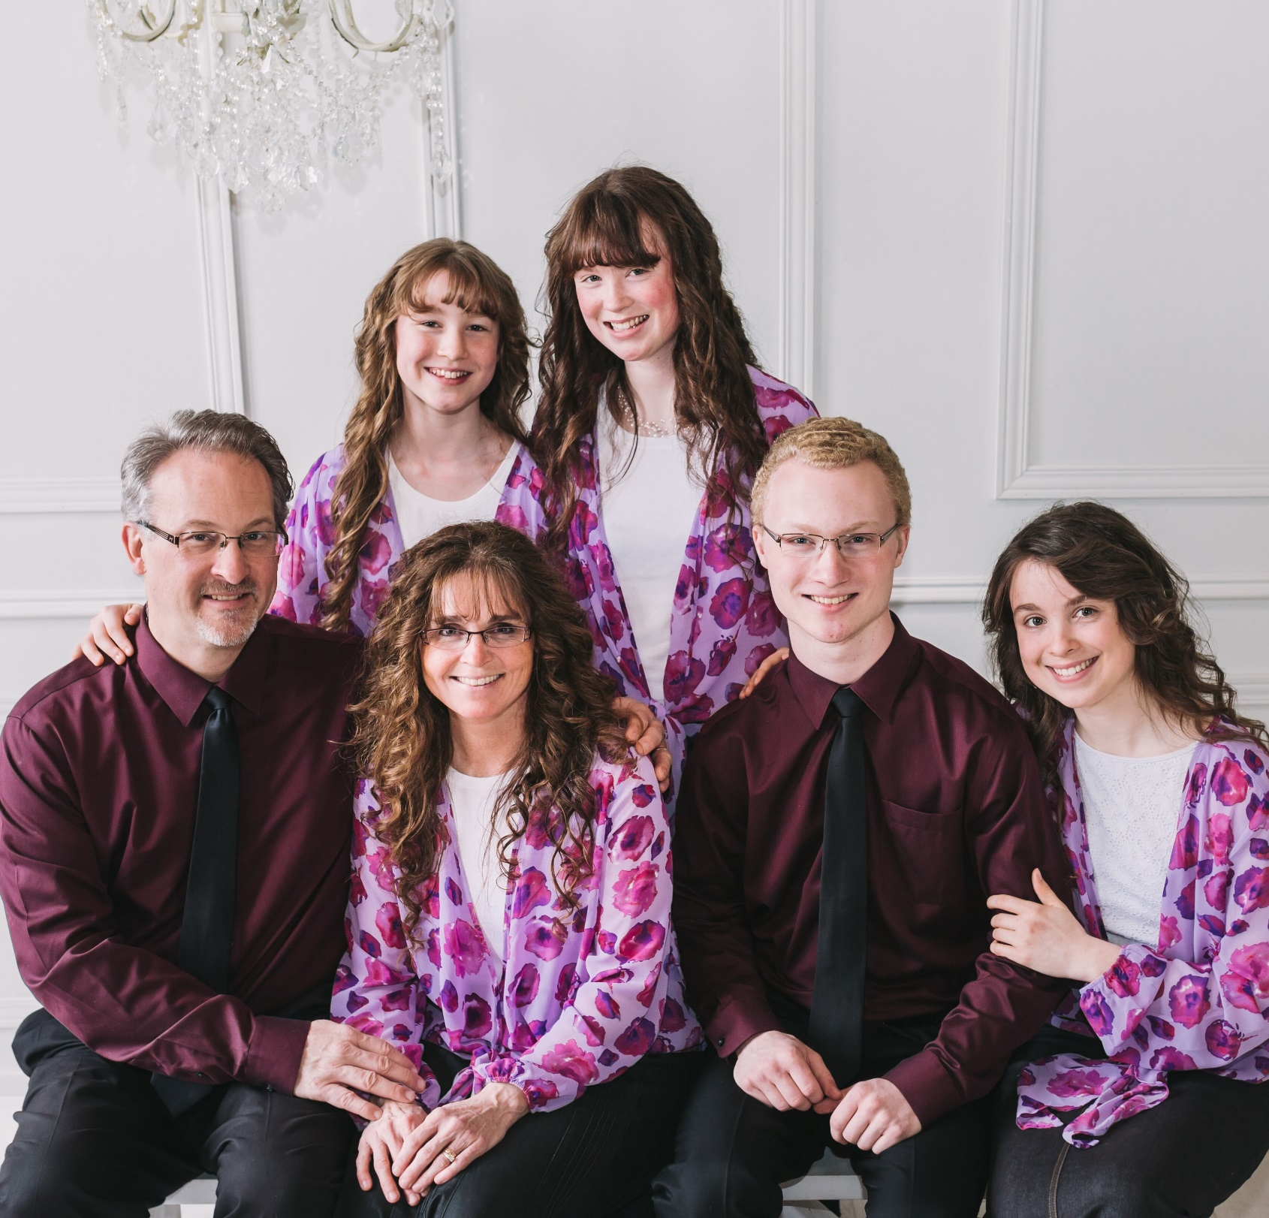

The Stiff Family

Bluegrass Gospel

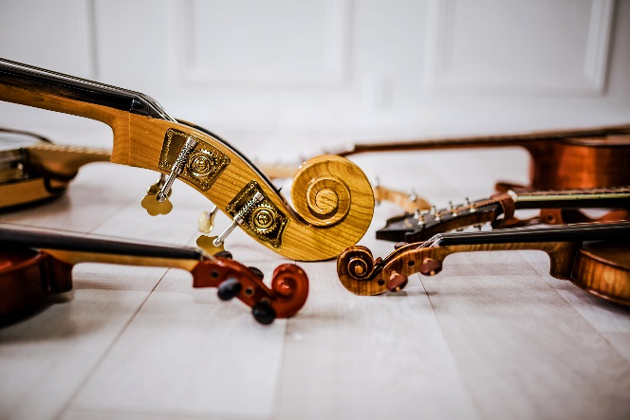

Date: _________________

Location: __________________

Time: _____________