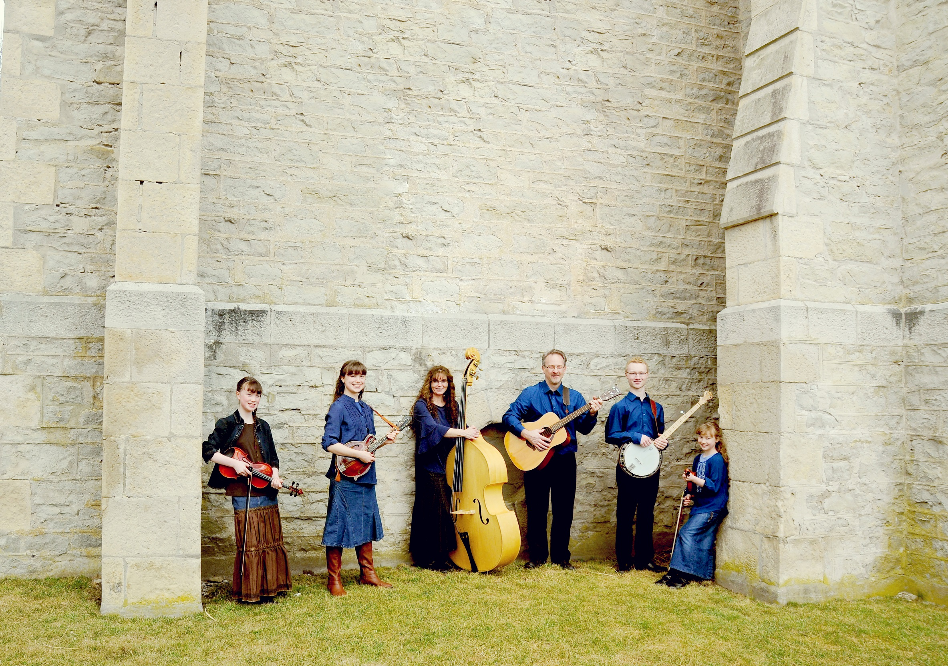

The Stiff Family

Bluegrass Gospel

Date: __________

Location: _____________

Time: ________